Year 12 ATAR PHYSICS 2020
Practical Test ELECTROMAGNETISM

Determining the field strength in a coil for an applied current.
Marks: /12

ANSWERS
Background:
When a current flows through a solenoid (a coil), a uniform magnetic field parallel to the sides of the coil is produced. The strength of the field (B) depends upon the current (I) applied.
Aim:
To apply a current in a solenoid and calculate the field strength produced inside the solenoid.
Equipment:
Current balance kit
Two ammeters (0-5A)
Two 12 V DC power pack
2 Rheostats
Connecting leads
Solenoid

Procedure:

- Set up the equipment as shown below. DO NOT TURN ON THE POWER.
- BALANCE THE LOOP so it is horizontal.
- When you have completed the circuit you raise your hand so that your teacher can check it.
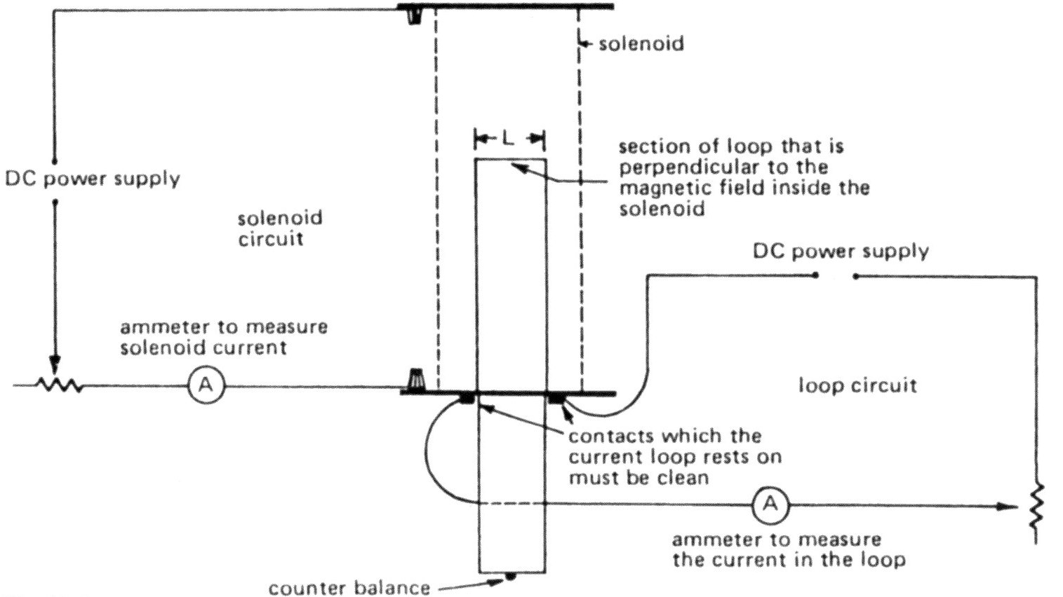
/3
-1 mark for each error. Ensure correct polarity of connections to meters.
No loss of marks if equipment problem.

/4

- Place a piece of the nichrome wire on the end of the loop.
/1

/4

Mass of wire = 2/100 x 0.701 g = 0.01402g
( 0.0140g 3sf)

- Switch on the circuit. Adjust the current in the solenoid and in the loop so that the loop is again horizontal.

Record results here: solenoid current = _____________ Loop current = ______________
/2

/4
Raise your hand so that your teacher can check your readings
-1/2 mark for each reading less than 2 significant figures

- Below is a diagram of the current balance setup:
SOLENOID

LOOP

F= mg
/1

/4
F= IlB

Complete the formulae in the boxes.
BOTH MUST BE CORRECT FOR 1 MARK

- Using the correct current value, calculate the field strength in the solenoid.
/4
1 correct I
1 correct l
+/- 0.001
1 mass in kg
1 answer

/4
mg = IlB B = 1.402 x 10⁻⁵ 9.8
I x 0.024m

B = 5.716 x 10⁻³/I T

= Ans (3sf, 2 ok) T

ANSWER: A current of ______A in the solenoid produces a field strength of __________
/1
1 correct solenoid current quoted

/4

